## 

Contents

Introduction: 1

Calculations: 1

Simulation 2

Explanation for noise observed 8

Conclusion 8

## Introduction:

## The aim of the project is to develop, build and test a power electronic converter which is designed to achieve pre-defined specifications. The converter is designed to accept an external supply of unregulated DC power within a specified input voltage variation. The converter is also able to deliver an output complying with specified limits of output voltage and output ripple under defined range of loading conditions.

The typology that is adapted in this project is the dual-switch, push-pull converter arrangement. The magnetics module (main inductor and transformer) is manually constructed to achieve designed value. Other electronic component is chosen to achieve best overall performance.

## Calculations:

**Feedback voltage control: Rf**

Pin 1 and pin 2 are the error amplifier input for voltage control, voltage different across pin 1 and 2 indicated that the voltage of output is different to the desired value. The voltage of pin 2 is 2.5 volt, which pre-set by resistors R1 and R3. Voltage for pin 1 must be 2.5 volt as well. That can be set by matching Rf with R4. The output voltage is 9V in our design. The value of Rf can be calculated by following:

$$\frac{9-2.5}{Rf}=\frac{2.5-0}{4.7}$$

Rf is 12.2k ohm.

**Current limiting control: RCL**

Pin 4 and 5 are the control for current limiting. When the voltage difference between two pins are greater than 200mV, the duty cycle of output drop about 25%, increasing the sensing voltage about 5% resulting a 0% output duty cycle. Pin 5 is connected to the power in ground and pin 4 is connected to the power out ground across R9. Since R9 is only a overcurrent protection for the chip, normally no current pass through R9, the voltage difference between pin 4 and 5 is the voltage across RCL. We need a RCL value would have a voltage drop about 200mV when 3.7A current pass through. The RCL value can be calculated by:

$$RCL=\frac{0.2V}{3.7A}$$

RCL is 0.054054 ohms.

RCL is a tiny value, so we use 4 resistors in parallel to achieve that value. RCL1 to RCL4 can by calculated by: $RCL1= 0.054054 x 4$ which is approximate 0.22 ohms.

**Operating frequency control: CT and RT**

The operating frequency for switching can be controlled by selecting different CT and RT value. CT control the dead time between switching and RT control the oscillator period. Notice that the outputs switch on every 2 oscillator cycle, one operating period is formed by 2 oscillator period. In our design, the operating frequency is 50kHz, that means the oscillator frequency we should select is 100kHz. In our design, we decided to have a 0.5us dead time to give us a little bit of margin for input voltage. By the figure on the data sheet, we choose CT to be 0.001uF. Then we choose RT to be 8.2k ohm to give us around 100kHz of oscillator frequency.

**Compensation: R_COMP and C_COMP**

For compensation pin 9. The voltage on pin 9 will increase when the duty cycle of output increase. We are not using that output; we choose R_COMP and C_COMP value to be 30k ohm and 0.01 uF as it is recommend in the data sheet for step-Down switching regulator.

## 

## Simulation

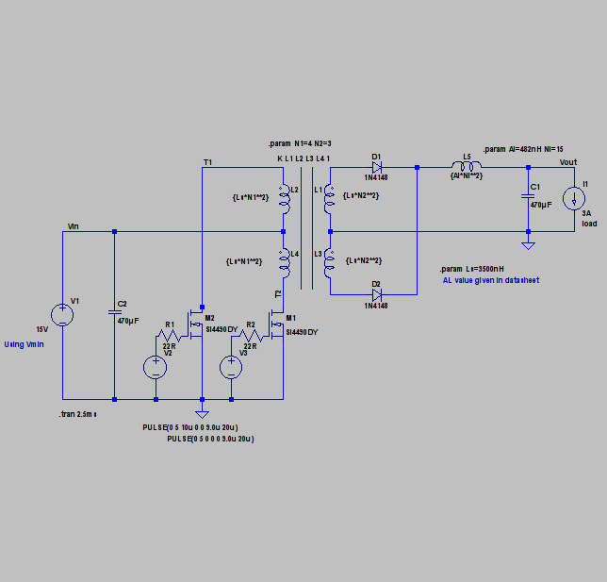

We performed a simulation using the LTSPICE software, which had 2 benefits:

1. It allowed us to obtain the theoretically idealised waveforms.

2. It provided a clear schematic for us to follow in putting together our converter.

The limitation of the SPICE software was that we could not find a way for to model transformers accurately. The exact values we obtained during our simulation did not match actual test values. It provided an estimate that we still found helpful.

**Analysis and Comparison of Waveforms**

In this section, we will observe the various waveforms and values we have obtained in testing our converter and compare them to the ideal values, both theoretically and as specified in the design requirements.

**1.**  **Voltage and Current across MOSFETs (T1 and T2)**

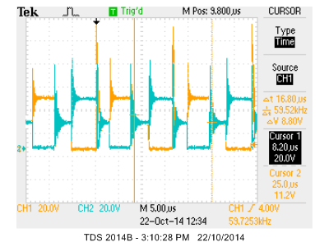

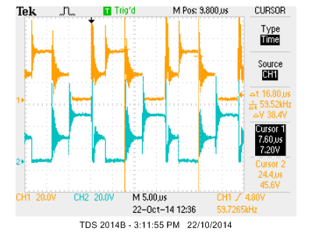

The two figures above show the voltages across the switches (MOSFETs) to the primary coil, both together and apart. It can be seen that they match the ideal waveform, as shown on the next page, quite closely.

Also noteworthy is the switching frequency that we have measured at 59 kHz which is slightly higher than the 50 kHz that we were aiming for.

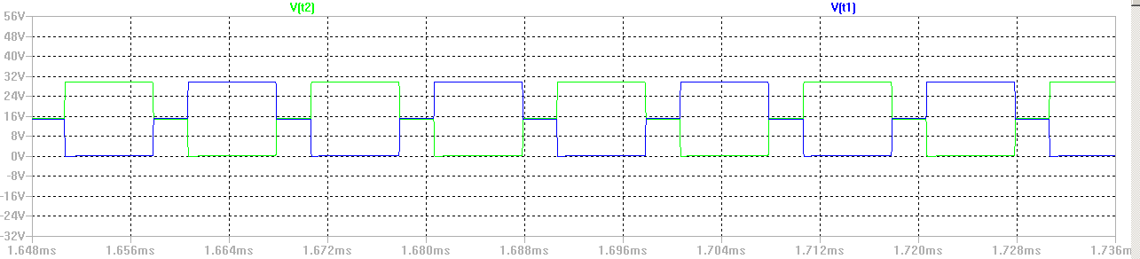

For the MOSFET current waveforms, we observed something that was highly irregular. We suspect that at the time we took the waveforms which was after the demonstration, one of our MOSFETs might have gotten fried. Therefore, the actual waveforms are unavailable.

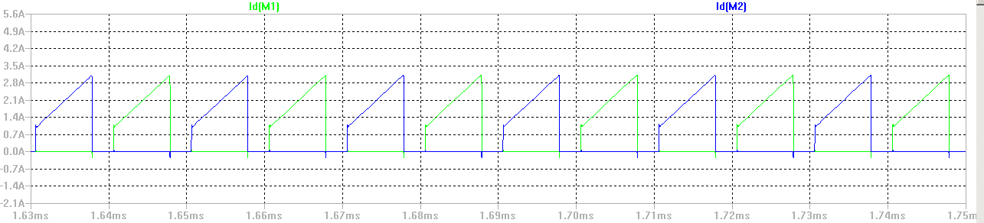

Ideal waveforms for the current flowing across both MOSFETs.

**2. Efficiency Calculation**

In order to determine the efficiency of our converter, we obtained these four values:

Note: Observations were performed with a 3 Ohm load.

Vin  = 21.5 V

Iin = 1.47 A

Vout = 8.77 V

Iout  = 2.98 A

Calculations:

Pin = Vin * Iin = 31.605 W

Pout = Vout * Iout = 26.1346 W

Efficiency = (Pout / Pin) * 100%

= 82.7%

The design specifications called for > 75% efficiency which we managed to satisfy.

**3. Iout**

We managed to achieve a value that was very close to 3 A (~2.98 A) across a 3 Ohm load while varying our input current from 15 V to 28 V.

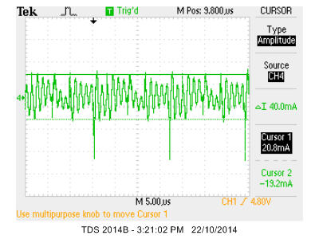

The figure above shows the ripple of the output current, which is about 40 mA.

**4. Vout**

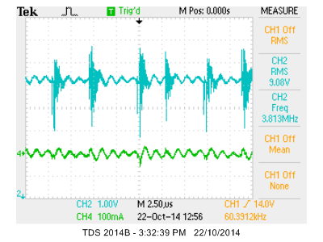

**Vout in Blue**

**Iout in Green**

This particular snapshot of the voltage waveform was taken at an input voltage of 21.5V, around the middle of our input range.

As can be seen, we have successfully achieved an output voltage of 9V which was required of us in the design specifications. This RMS value remained steady with a small variation of +- 0.1V when we varied the input voltage from 15 – 28 V.

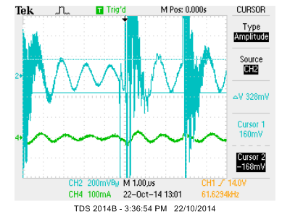

The figure above shows the same two waveforms, zoomed in. Using the cursor, we measured out output ripple voltage at 328 mV which satisfies the requirements.

**5. Current across diodes**

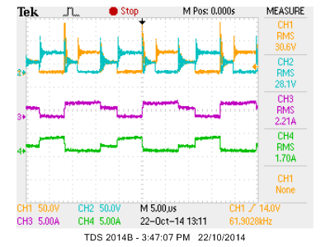

The blue and yellow waveforms represent the voltage across the MOSFETs, used as a reference.

The purple and green waveforms represent the current across the secondary diodes.

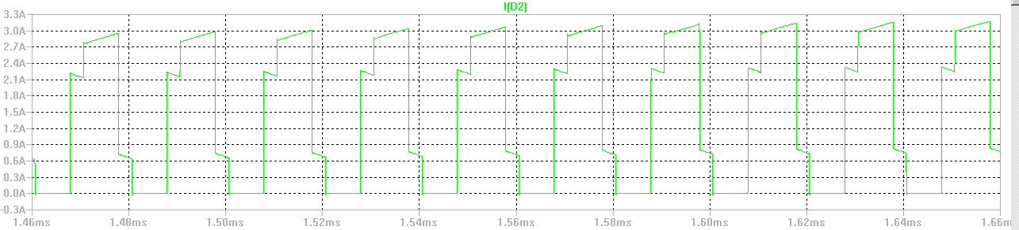

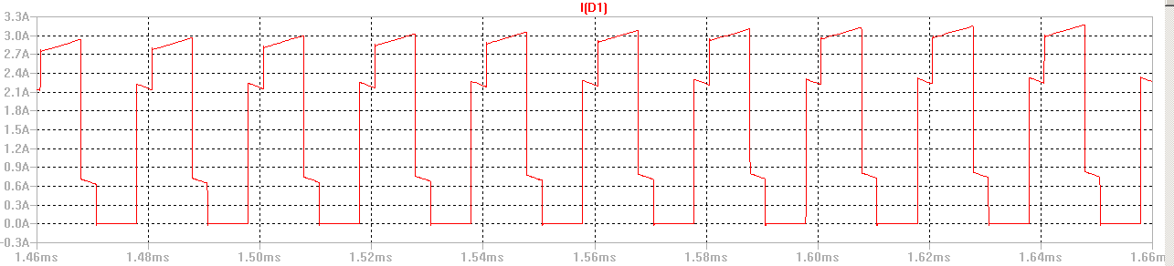

The ideal waveforms show symmetry between the two diodes (out of phase). Our observed waveforms seem to be slightly erroneous in that one of the diode currents is wider than the other (purple > green). We suspect that this is due to one of the diodes reacting faster than the other.

**6. Current across Inductor (IL)**

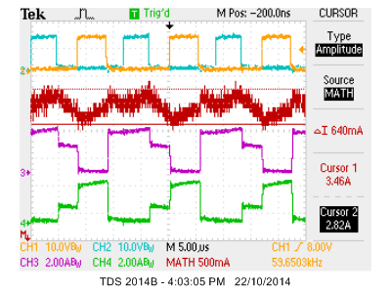

The red waveform is the addition of the two diode voltages (ID1 + ID2) which should combine to give us the current across the inductor. Due to the resolution being poor, we have measured the inductor current directly shown in the figure below.

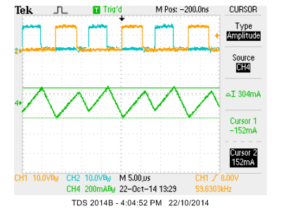

The inductor current is shown in green and has a ripple of 304 mA measured using the cursor, which is within specifications.

## Explanation for noise observed

Firstly, we considered Gaussian noise which arise due to unavoidable thermal processes. However, such noise would only contribute a relatively insignificant amount of noise. Switched mode power supply causes undesirable noise. When MOSFET driver switch, they create a transient current demand on the power supply. This is the primary source of noise. Such events can happen at random times, though it tends to be at switching frequency and its harmonics. A high frequency burst of noise may appear due to track capacitance and inductance at the switching instant. Although output capacitor helps to smooth the output ripple, they also create damping oscillations due to low frequency resonance.

Because of the slightly asymmetry in the push-pull converter, it may induced noise and further affect the output quality. In a heavy loading condition, the load resistance is small enough so that wire resistance can no longer be ignorable. Even combined with other non-ideal components, these factors should have relatively small impact on the overall converter performance.

An improvement that can be considered in the future to reduce this noise is the addition of a snubber circuit than should cut down on these transients.

## Conclusion

In the process of completing our design, we learned a lot regarding the design process. The number of factors that have to be considered can be overwhelming, if not for certain design choices being restricted to us. We have come to a closer understanding of design as an iterative process, where detailed calculations should take us close but not all the way to our final design. The final steps taken should be to tweak the values (resistors and capacitors in our case) according to the results we are obtaining. We are optimistic that this converter design has put us on the path to being able to design a converter with less guidance in the future.